Milestone 1

WEB601

Daniel Musgrave

2019

Contents

Introduction 3

Site Info 3

Mission and Purpose 3

Goals 3

Target Audience 3

Incentive 4

User Experience 4

Audience 4

Scenarios 4

Scenario 1 4

Scenario 2 5

Competitive Analysis 5

Site Content 6

Pages 6

Content Requirements 7

Site Structure 7

Metaphor Exploration 7

Site Structure Listing 7

Architectural Blueprints 8

Define Navigation 8

Visual Design 9

Wireframes/Mockups 9 11

# Introduction

This document describes the design of a portfolio website that is used to view the work of, and contact the owner. The site will be used both to organize part-time, and long-term work. Tools used to develop the site include JavaScript, React and source control tools (Git, GitHub).

# Site Info

## Mission and Purpose

The purpose of this site is to create a centralized hub for all of the various services that I can provide for people, acting as both a portfolio and a means of organizing work with potential clients. The site itself acts as a gallery showcase of the work that I have created in each field, each in their own section of the site. Clients can then contact me directly through the site to arrange any paid jobs they require my skills for.

No purchases will be made directly on the site, but they will rather be organized privately through email and/or other text chats.

## Goals

The main goal of this site is to connect myself with potential clients and/or employers through the means of presenting my works and achievements in an organized gallery format, so that paid work can be arranged to deliver a product (Whether it is premade such as a 3D model/asset, or a requested original work).

The short-term goal of the site is simply to find small jobs to complete for a fee, although in the long run, being a portfolio site, the overall goal is to present all of my work in one place so that potential employers will be able to view my projects and/or contact me for work.

## Target Audience

My target audience varies between each service. For example, image restoration and coloration would likely target older generations (Adults-Seniors) who will own photos that have degraded over time or were taken in black and white and would like to have colorized. Other photo manipulations would likely be requested from younger generations which would involve processes such as touching up photos and removing unwanted objects.

The site will also target adults working in the IT industry, as most of my skills are in that department and the portfolio will be used when applying for jobs, so it needs to look attractive and well laid out for any potential employers to look through.

## Incentive

The most common incentive for visiting the site will be to browse my gallery in order to decide whether to use my services or not. For example, someone looking for a certain photo manipulation on an image they own may visit the site to view my similar works and determine whether they would like to work with me or not. For employers, their incentive will be similar in the sense that they are looking at the examples of work that I have done in the past.

Being a portfolio site, most users will not simply stumble upon it from a google search, rather they would likely be referred or recommended it (by myself or others).

# User Experience

## Audience

As the site will be used by people with varying ranges of ‘tech’ skills, the site needs to clearly be readable and navigable for all visitors, this means keeping headers and links clear, concise and visible so as to be accessible by all audiences, young and old.

## Scenarios

### Scenario 1

James Sullivan is a retired man who wishes to restore an old dilapidated photo of him and his old childhood friend that has faded and creased over the many decades that he has owned it. He searches on Bing to find a site that can help him and stumbles across the portfolio site.

He sees that the main screen advertises Photoshop jobs, which include image manipulation and *restoration,* so he clicks the ‘*Photoshop’* item in the navigation bar at the top of the website. He browses the various example photos that are visible on the page and is happy with the way the final images look.

At the top of the page, he sees a large, bright button stating to contact the site owner directly to organize a job, he clicks it and is taken to the contact page of the website where he is able to send a message using his email.

### Scenario 2

Mike W. works for an IT based around educational game development for young audiences in schools, he is looking for a developer to join his new project that he plans to create in the near future. He has seen various games that have been worked on by a certain person who also happens to be in the same area as him, so he decides to see if he is available to work.

He visits the portfolio site and is greeted with an overview of some of the games that he has worked on in the past, he sees a button in the navigation bar that leads to a whole page centered around game development and clicks on it. On the page is detailed information on the experience with game development that he has, he decides that he would like to contact the developer in regards to some further inquiries, so he navigates to the footer of the page and finds the developer’s email, which he then uses to contact him with his queries.

## Competitive Analysis

It is rather tough to find portfolio sites that feature the same content is this site, however a few sites found that are somewhat similar are as follows:

<https://wolfvanveen.art/>

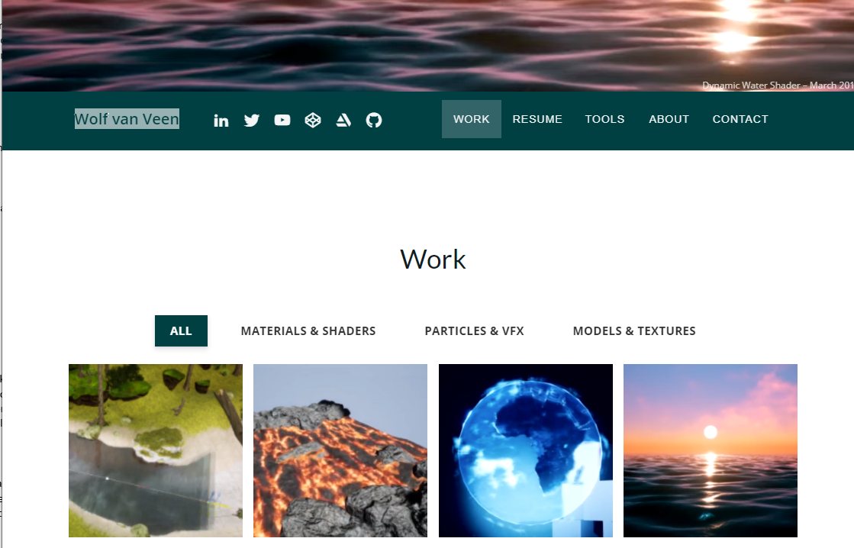

Wolf Van Veen takes a similar approach to that that is planned for this site, having categories in regards to each creative field that he can provide (Shaders, particle effects, models, textures), similar to this site, he does not display much text when showing his work, as most of the images are animated GIFs that display the effect in action, which is much more effective than describing the effect with text.

A main difference between Wolf’s site and this site is that despite having a navigation bar on the page, all of his content is on one single page of the site, and the nav bar simply scrolls down to the corresponding section on the page.

This does make the site much more simplistic and concise, which is good for a portfolio, but could also have its downsides. For example, on the machine that I viewed the website on the site would take quite a while to load due to the amount of media it would be loading on the page, and scrolling made it run quite slowly, meaning that the site somewhat sacrifices performance for compactness.

# Site Content

### Pages

**Landing Page**

The landing page of the site contains a summary of the various skills I have to offer, featuring snippets of descriptions of my experience with the field. This page acts as more of an introduction/resume rather than a presentation of products like the rest of the site, it is tailored to people who are visiting to learn about my skills rather than looking for something in particular (although various links will be used in the descriptions leading to their respective products).

**Photoshop Page**

This page is the hub for all of my Photoshop related skills, this page will aim to have very little text displayed by default, as it is centered around the images displayed. When hovering over an image, more information will be displayed to give the user more details about the product.

**3D Models/Assets Page**

This page is similar to the photoshop page, however there will be more focus on displaying text along-side the images by default, with details on the product.

**Game Development Page**

This page is much more text focused (with images still), that covers the various protypes and projects that I have been a part of relating to aspects of game development, including both personal game prototypes and assets that I have created for other people’s game projects for game jams such as Ludum Dare.

## Content Requirements

**Fonts**

All fonts used on the site will be sourced from Google Fonts, which allows sites to obtain fonts easily and fast simply by entering a url in the header of their site, all text will be sans serif in order to maintain a clean and modern style to the site, using bold fonts such as Roboto Bold for headings and clean, readable fonts such as Open Sans for the text bodies, both of which will fallback to default sans-serif fonts if unable to be retrieved when entering the site.

**Media**

Being a portfolio, all media (in this case, images and text) is created by the owner of the site and sourced from their own various projects, making it easy to use images without having to worry about any copyright issues that may be involved.

**Color**

The site uses a light, flat color screen that uses contrasting colors for the navigation, main content, and footer of each page to ensure that all content on the site stands out and is easily readable. All buttons will use the same bright color (the same color as the site navigation) in order to both stand out and implement a call to action effect for the visitor.

# Site Structure

## Metaphor Exploration

There is not much skeuomorphism visible on this site that I can think of, aside from perhaps various icons related to contact methods in both the footer, and the contact page of the site. (Email icon, chat icon, phone icon, etc). Being a portfolio site most of the content is centered around varying areas rather than being a static site that would incorporate metaphors similar to that of a library website. Common and recognizable social media icons will also be listed (Twitter, facebook, etc).

## Site Structure Listing

This site will only be made up of 5 pages that are all top-level, there are no sub-pages currently, and more pages may be added if the owner decides to make more services available in the future, which is a high possibility.

## Architectural Blueprints

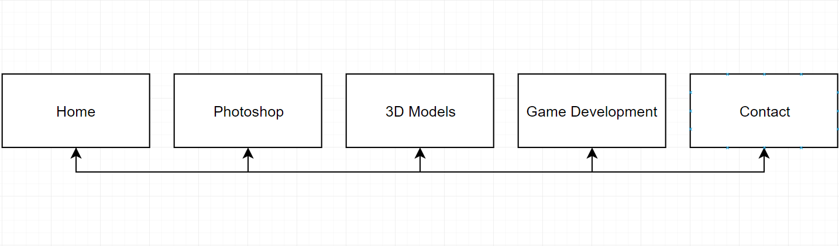

## Define Navigation

**Global**

All pages on the site contain a series of links in the navbar at the top linking to the other pages of the site, such as the landing page, photoshop gallery, 3D model gallery, and contact page.

**Local**

The main local navigation that I plan to have on my site is through the use of hyperlinks on the various galleries that link to the contact page, for example a button at the top of the gallery stating that if the user wishes to discuss a potential job, to visit my [contact] page, with a hyperlink to that page of the site.

On the home page, hyperlinks will be used on various featured projects, linking to their respective project pages.

# Visual Design

## Wireframes/Mockups

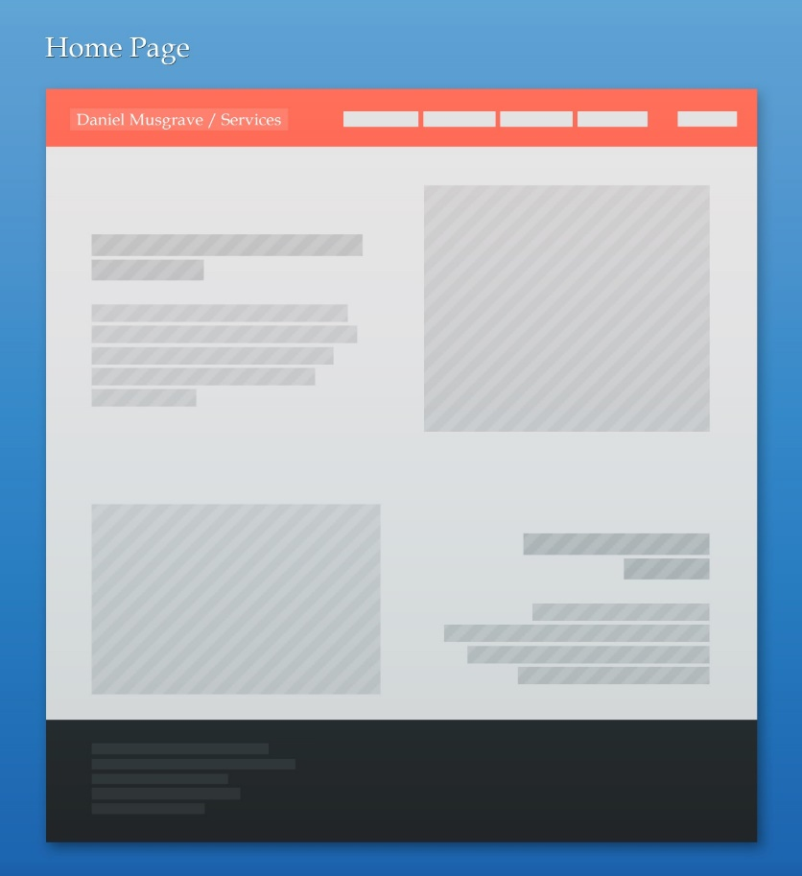

**Content**

The main topic of this page is to introduce the owner and highlight some of their notable work, it will include images displayed alongside text describing the experience that the owner has in those fields and what they can do.

**Layout**

Visually, this page displays a number of segments that switch between left and right aligned content to separate each section, this could also be combined with a ‘fade-in’ effect as the user scrolls down the page.

**Functions**

Each section’s header will link to their respective location on the site, and the navigation bar at the top of the page navigates to every other page on the site. In the footer are various social media links along with contact information.

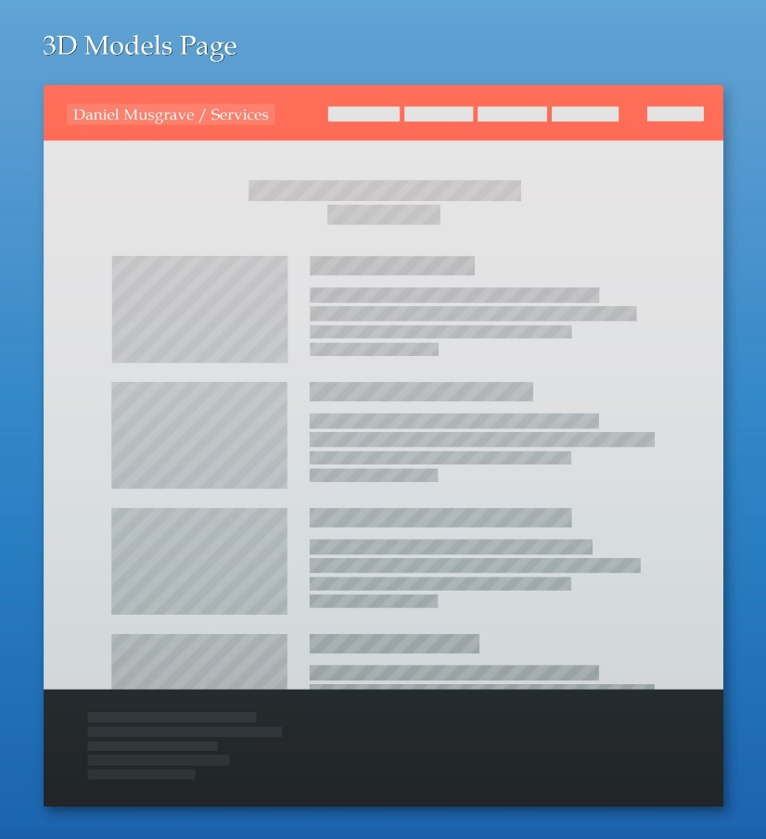

**Content**

This page displays information about a 3D model (such as techniques that may apply, vertex/triangle counts, what it was used for (if anything), along with an image of the model itself.

**Layout**

The text is secondary on this page as the images of the models are the main focus, therefore the images are slightly larger than those on the game development page, as there may be smaller details on the models that require a larger image to make apparent.

**Functionality**

Clicking on the button at the top of the page brings the user to the contact page of the site where they can query the other about any 3D model related jobs that they might want to pay for.

Other functionality includes the aforementioned navigation and footer hyperlinks.

## 

**Content**

This page mainly just features images at first, with various works that the owner has completed in the past.

**Layout**

As all of the images will likely be a different size, the gallery is displayed an a split column layout, where columns are horizontally even sized but not vertically allowing for a dynamic gallery that does not scale images disproportionately.

**Functionality**

Hovering over an image or clicking it will reveal a few more details of the image, namely a description of what process was performed on the image (Object removed, photo restored, etc).

Clicking the button at the top of the page will bring the user to the contact page to ask about getting a photoshop job done.

Other functionality includes the aforementioned navigation and footer hyperlinks.

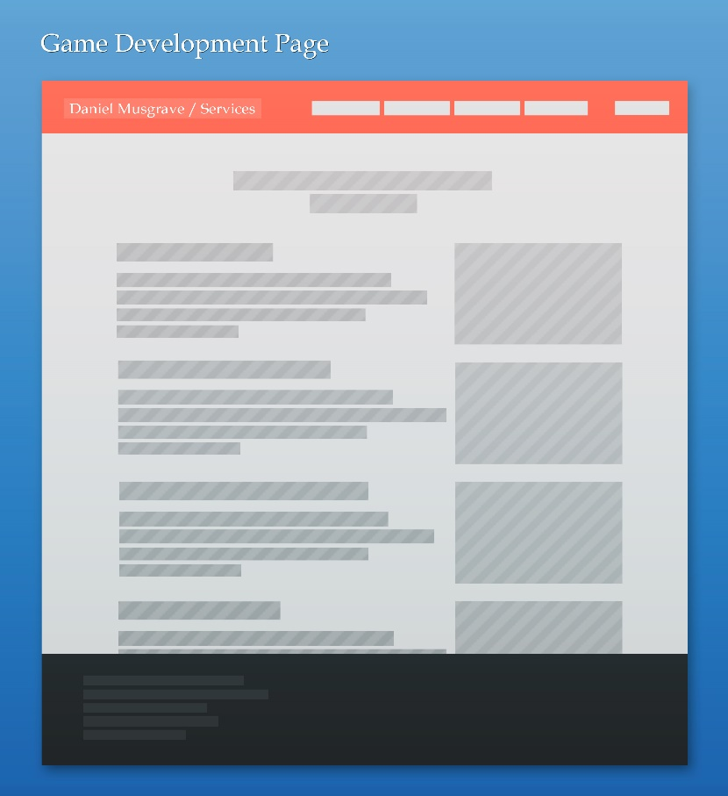

**Content**

This page outlines various games that I have worked on or been a part of, it simply contains a brief description of what I worked on accompanied by an image of the project.

**Layout**

The images on this page are right-aligned, this is because more emphasis is put on the text on this page and the images are more just to provide context rather than be the main focus.

**Functionality**

The button at the top of this page links to the contact page, allowing the user to message the owner if they would like to organize a game development related job.

Other functionality includes the aforementioned navigation and footer hyperlinks.

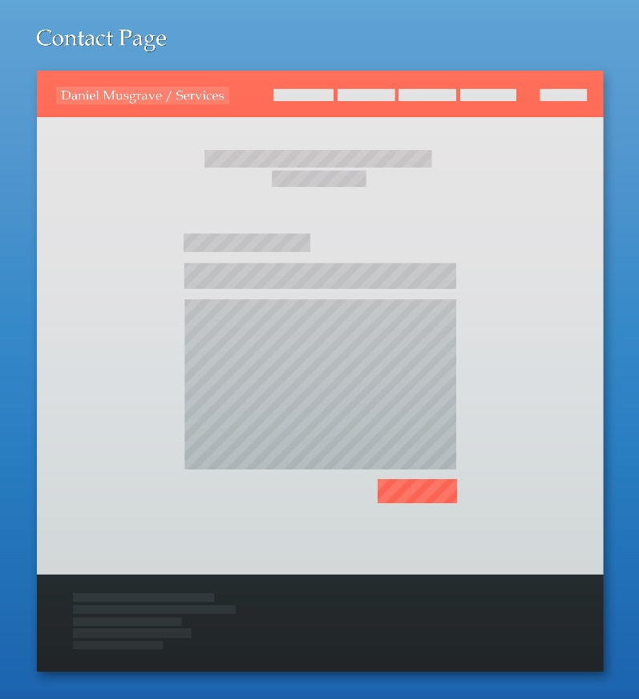

**Content**

This page solely features an input form which the user can use to send a message directly to the site owner.

**Layout**

This page is center-aligned as it is focused primarily on the input form.

**Functionality**

Below the form is a bright orange ‘Submit’ button, which is used to send the message (which goes to the owner’s email).

Other functionality includes the aforementioned navigation and footer hyperlinks.